Secure-explainable-ai-mathematics
Explainable AI for Enhancing Conceptual Understanding in GCSE-Level Mathematics Education

This is a secure educational web application built with Flask, SQLite, MongoDB, machine learning, and rule-based mathematical logic. It is designed to support students in developing a deeper conceptual understanding of GCSE-level mathematics by guiding them through appropriate solving methods, clear reasoning, and structured explanations.
This application was developed as part of a Data Science and Artificial Intelligence project. It demonstrates secure coding, responsible AI use and data-driven system design

Table of Contents
1. Overview
2. Key Features
3. System Architecture
4. Installation Guide
5. How to Run the Application
6. Teacher/Admin Guide
7. Student Guide
8. Security Features
9. Databases Used
10. Explainable AI Logic
11. Testing
12. Repository / GitHub Activity
13. Limitations
14. Future Improvements
15. Author

1. Overview
The Secure Explainable AI Mathematics application is a Flask-based web system that integrates machine learning with rule-based mathematical logic to recommend suitable solving methods. The system processes user input, applies a trained classification model, and combines this with structured logic to provide clear method recommendations and explanations. It also includes an interactive dashboard with topic-based sections, allowing users to explore different areas and receive guided support in a structured and accessible way.
The application currently supports five key maths topics:
• Quadratic Equations
• Simultaneous Equations
• Ratio
• Sequences (Geometric Progression)
• Sequences (Arithmetic Progression)

The system supports two user roles:
• Teacher/Admin – can access the dashboard, manage questions, create and delete users, delete questions, and change password.
• Student – can log in securely, access learning topics, view recommended methods, use the system for guided maths support, and change password.
This application combines:
• SQLite → user accounts and question storage
• MongoDB → analytics logging and usage tracking
• Machine Learning + Rule-Based Logic → method recommendation and explainable reasoning

User Permissions
Feature | Student | Teacher/Admin
View questions | ✔️ | ✔️
Input your own questions | ✔️ | ✔️
View explanations | ✔️ | ✔️
Add questions | ❌ | ✔️
Delete questions | ❌ | ✔️
Create users | ❌ | ✔️
Delete users | ❌ | ✔️
Change password | ✔️ | ✔️

2️. Key Features
- Secure Login and Role-Based Access
• Users must log in before accessing the dashboard.
• Teachers and students have different permissions.
• Teacher-only actions are protected through role-based access control.
• Passwords are stored securely using hashing.

- Explainable Maths Support
- Recommends suitable methods
- Explains why the method works
- Explains why other methods may not apply

- Topic-Based Dashboard
Students and teachers can use a structured dashboard with a topic selector. This avoids long scrolling and makes the interface cleaner and more focused.

- Hybrid AI Decision Layer
The application uses a combination of:
• trained machine learning model
• TF-IDF vectoriser
• rule-based mathematical logic
The rule-based logic acts as the authority layer so that recommendations remain mathematically reliable.

- Teacher/Admin Management Tools
Teachers can:
• add questions
• delete questions
• create users
• delete users
• change password

- Multi-database system (MDBS)
The system uses two databases:
• SQLite
• MongoDB

- Custom Error Pages
The application uses customised 403 and 404 pages instead of default Flask error responses.

- Testing Approach
• Unit testing: Tested individual components to ensure they work correctly on their own.
• Integration testing: Checked that different parts of the system work together properly.
• End-to-end testing: Tested the full system workflow from user input to final output.
The testing approaches confirm that the application behaves correctly, securely, and reliably.

3. System Architecture
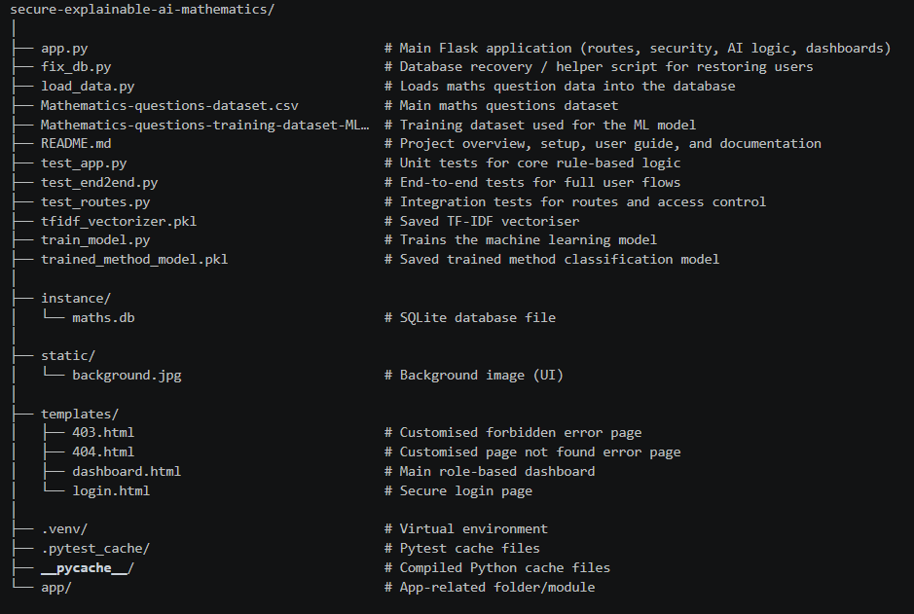
The system architecture overview shows the overall structure of the system, including the Flask application, machine learning components, databases, templates, and testing modules. It highlights how different parts of the system are organised and work together to support secure, intelligent, and explainable mathematical problem-solving.

System Flow
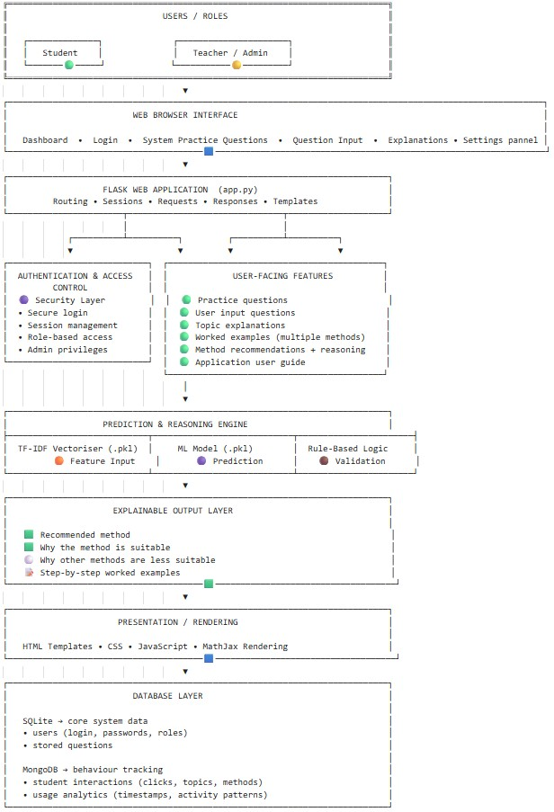
The system workflow overview shows how the system processes user input and generates output. It shows how the Flask application processes user inputs, which are then passed through the prediction and reasoning engine (machine learning and rule-based logic), and transformed into explainable outputs. It also highlights the integration of security controls, user features, and the database layer in supporting a secure and structured learning experience.

4. Installation Guide
Requirements
• Python 3.10+
• pip (Python package manager)
• MongoDB Community Server
• Visual Studio Code (recommended)

Step 1: Clone or Download the Project
git clone <https://github.com/DonaldsonLTU/Secure-explainable-ai-mathematics>
cd secure-explainable-ai-mathematics

Step 2: Create and Activate Virtual Environment (Recommended)
Activate python -m venv .venv

Step 3: Install Dependencies
pip install flask flask-wtf flask-sqlalchemy werkzeug pymongo joblib scikit-learn flask-limiter

Step 4: Ensure Required Files Are Present
• trained_method_model.pkl
• tfidf_vectorizer.pkl
• Question dataset files
• templates/ and static/ folders

Step 5: Set Environment Variables
set SECRET_KEY=your-secret-key

Step 6: Ensure MongoDB is Running
• Open MongoDB Compass OR start MongoDB service
• Default connection: mongodb://localhost:27017/

Step 7: Load Initial Question Data
-python load_data.py

Step 8: Run the Application
python app.py

You should see: Running on http://127.0.0.1:5000

Step 9: Access the Application

Open your browser and go to: http://127.0.0.1:5000

5. Using the Application
-Login:
Users begin at the login page and enter their username and password.
-Dashboard
After successful login:
• students are taken to a guided learning dashboard
• teachers are taken to a dashboard with both learning tools and management features
-Topic Selection
Users select a topic from the dropdown menu:
• Quadratic Equations
• Simultaneous Equations
• Ratio
• Geometric Progression
• Arithmetic Progression
Once a topic is selected, the relevant topic card appears.

-Question Interaction
Students can:
• select a question
• see the recommended method
• view why that method is suitable
• open additional explanation content
• view solving methods and worked examples
• insert their own question

-Logout:
Users can log out securely at any time.

6. Teacher/Admin Guide
Teachers have extended permissions and can manage the learning system.
Teacher tools include:
• Add Question
Teachers can insert a new maths question into the SQLite database.
• Delete Question
Teachers can remove questions using the question ID.
• Create User
Teachers can create new student accounts.
• Delete User
Teachers can remove user accounts from the system.
• Change Password
Teachers can securely update their own password.
• View Question Table
Teachers can view the full question management table on the dashboard.

Teacher journey
Login
|
Dashboard
|
+-- Select a maths topic
+-- View method recommendation
+-- Add question
+-- Delete question
+-- Create user
+-- Delete user
+-- Change password
|
Logout

7. Student Guide
Students use the system as a guided learning tool.
Student features:
• secure login
• access to the topic selector
• recommended maths methods
• explanation of why a method works
• structured topic-based learning support
• password change option
Student restrictions:
• no teacher-only admin controls
• no question management table
• no ability to create or delete users
• no ability to delete questions

Student journey
Login
|
Dashboard
|
+-- Read welcome message and learning guide
+-- Select topic
+-- Choose question
+-- View recommended method
+-- Read explanation
+-- Continue practice
|
v
Logout

8. Security Features
The system includes multiple security protections:
✔ Authentication and Login Protection
Users must log in before accessing protected routes. This prevents unauthorised dashboard access.
✔ Password Hashing
Passwords are stored securely using Werkzeug hashing rather than plain text.
✔ Role-Based Access Control (RBAC)
Teacher-only routes and functions are protected using login_required and teacher_only decorators.
✔ Secure Session Handling
The application uses session cookies with secure configuration, including HTTPOnly session protection.
✔ CSRF Protection
All forms are protected using Flask-WTF and CSRF tokens.
✔ Input Validation and Sanitisation
User input is validated through Flask-WTF and controlled processing logic.
✔ Rate Limiting
Login attempts are limited to reduce brute-force attacks and abuse.
✔ Environment-Based Configuration
Sensitive configuration, such as the Flask secret key, is environment-aware, with environment variable support.
✔ Security Headers
The application applies headers such as:
• X-Content-Type-Options
• X-Frame-Options
• Content-Security-Policy to reduce information disclosure and browser-based attacks.

STRIDE Mapping
The implemented security measures align with STRIDE:
• Spoofing → authentication, password hashing, session security
• Tampering → input validation, CSRF protection
• Repudiation → session-controlled user actions
• Information Disclosure → hashing, security headers, safe error pages
• Denial of Service → rate limiting
• Elevation of Privilege → role-based access control

9. Databases Used
-SQLite
SQLite stores:
• user accounts
• hashed passwords
• user roles
• maths questions
• recommended method labels
• method reasoning text
SQLite Tables (Structure)
- users: (id, username, password, role)
- questions: (id, text, method, reason)

-MongoDB
MongoDB stores:
• student interaction logs
• usage history
• topic selection events
• recommended method events
• timestamps
MongoDB Collections
- interactions: stores user activity data
- logs: stores system and usage logs
MongoDB is used because it supports flexible analytics logging and future interaction analysis.

10. Explainable AI Logic
This system does not rely only on machine learning predictions; it uses a hybrid approach consisting of:
- Machine Learning Layer
A trained Random Forest classification model predicts a method recommendation from question text using:
• TF-IDF vectorisation
• saved classification model

- Rule-Based Logic Layer
The system then applies topic-specific mathematical rules to verify the machine learning suggestion.
This hybrid design improves reliability and makes the system more suitable for educational use.

11. Testing
Testing was implemented to ensure the system is reliable, secure, and works correctly.
- Unit Testing
Unit tests were used to verify core method-selection logic independently.
The tests confirmed correct behaviour for:
• quadratic method logic
• simultaneous equations logic
• ratio logic
• geometric progression logic
• arithmetic progression logic

- Integration Testing
Integration tests were used to verify that system components work together correctly.
These tests confirmed:
• login route handling
• form submission behaviour
• dashboard access after login
• protected route behaviour

- End-to-End Testing
End-to-end tests were used to simulate real user journeys in the system.
These tests confirmed:
• teacher login, dashboard access, and logout
• student login and restricted access behaviour
• topic page loading and full interaction flow

Overall, the inclusion of unit, integration, and end-to-end testing strengthens confidence in the system’s reliability and security.

12. Repository / GitHub Activity
The project was developed using Git and GitHub with clear version control practice.
This includes:
• meaningful commits
• development progress
• testing commits
• UI refinement commits
• project documentation updates
This demonstrates a structured development workflow and good software engineering practice.

13. Known Limitations
• Limited dataset size may affect model performance
• System currently supports only five topics
• Machine learning model is not 100% accurate
• System depends on structured user input for best results

14. Future Improvements
• Use a larger and more diverse dataset
To improve model accuracy and handle a wider range of mathematical problem types.
• Expand rule-based mathematical logic
To improve reliability and ensure correct method recommendations across more complex scenarios.
• Increase the range of worked examples
To cover more question structures and help students find examples closer to their own problems.
• Support more complex mathematical structures
Such as powers, roots, and advanced fractions to improve system coverage.
• Add layered explanations
Allowing students to move from simple explanations to deeper conceptual understanding.
• Introduce an answer-checking feature
So students can input their own solutions and receive feedback on errors.
• Expand the system to include more maths topics beyond the current five

15. Author
Donaldson Mordi
Explainable AI for Enhancing Conceptual Understanding in GCSE-Level Mathematics Education
Leeds Trinity University

